dataset we got following files :

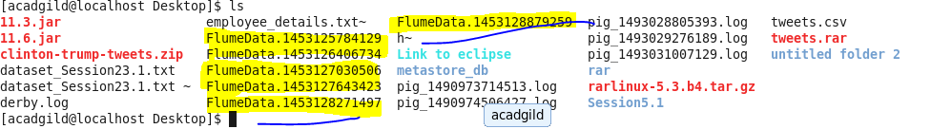

pig script:

For file FlumeData.1453125784129:

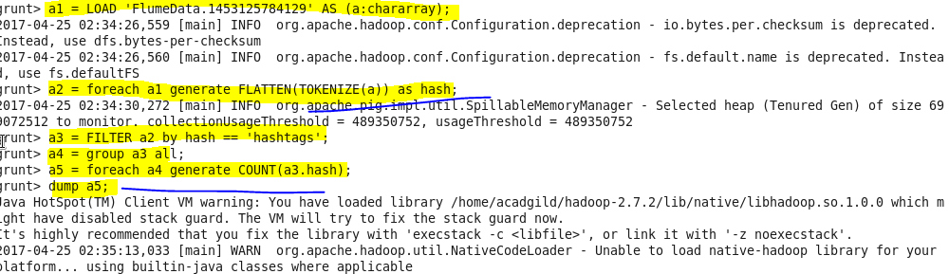

Output :

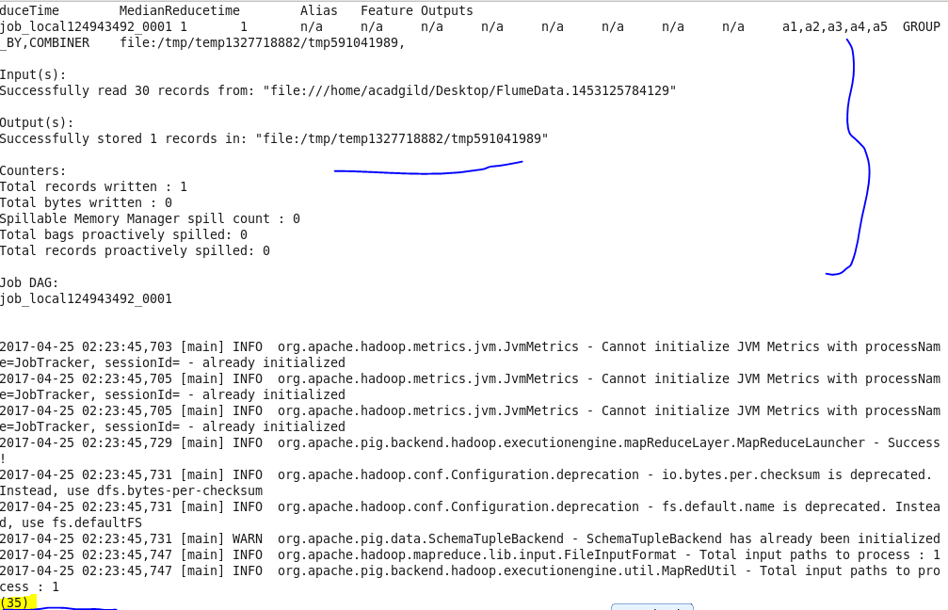

For file FlumeData.1453126406734:

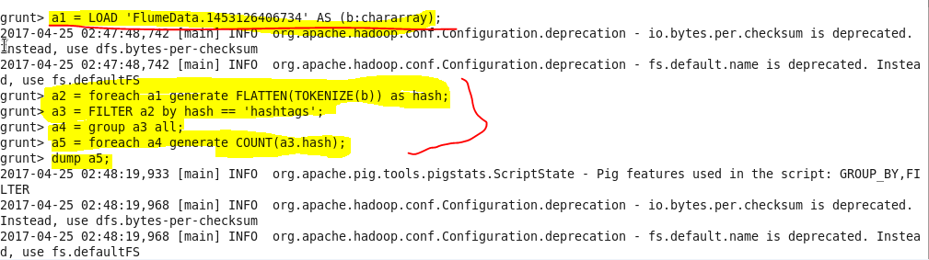

Output :

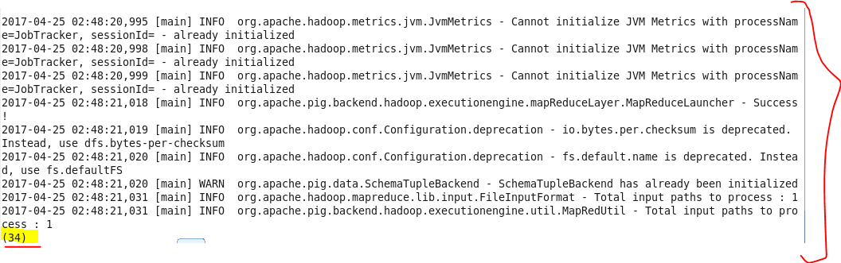

For file FlumeData.1453127030506:

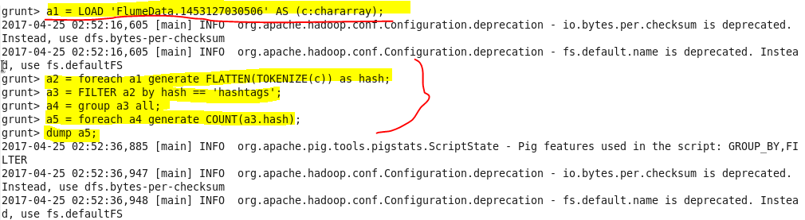

Output :

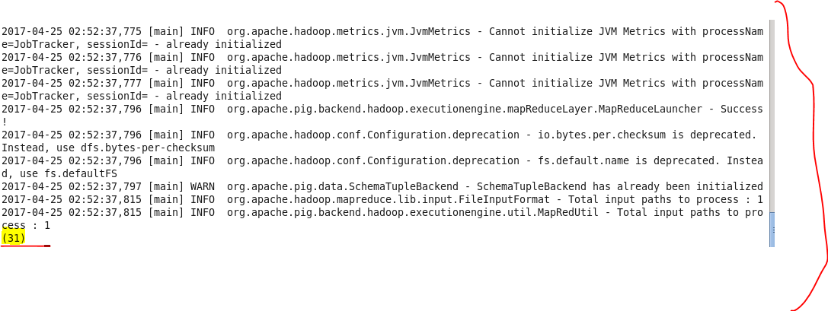

For file FlumeData.1453127643423:

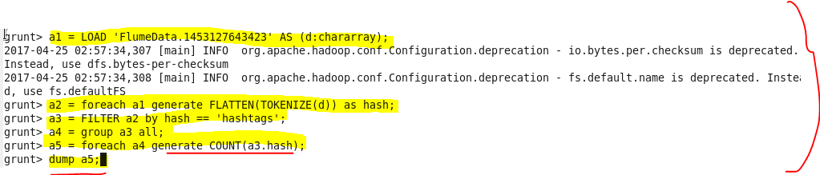

Output :

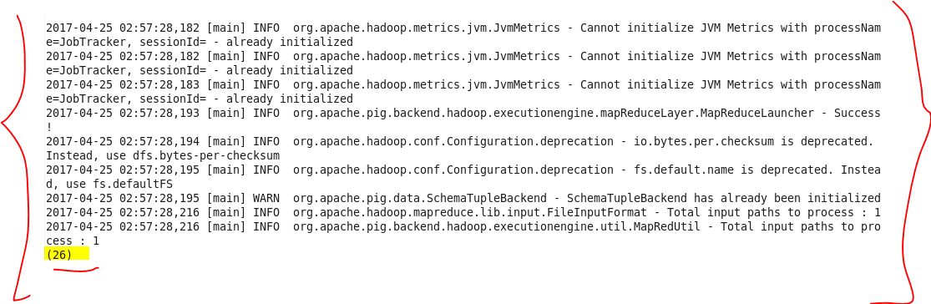

For file FlumeData.1453128271497:

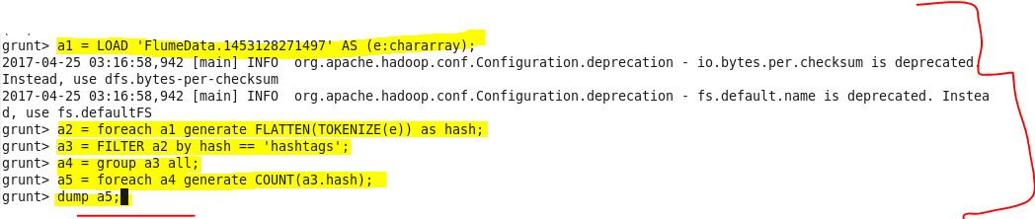

Output :

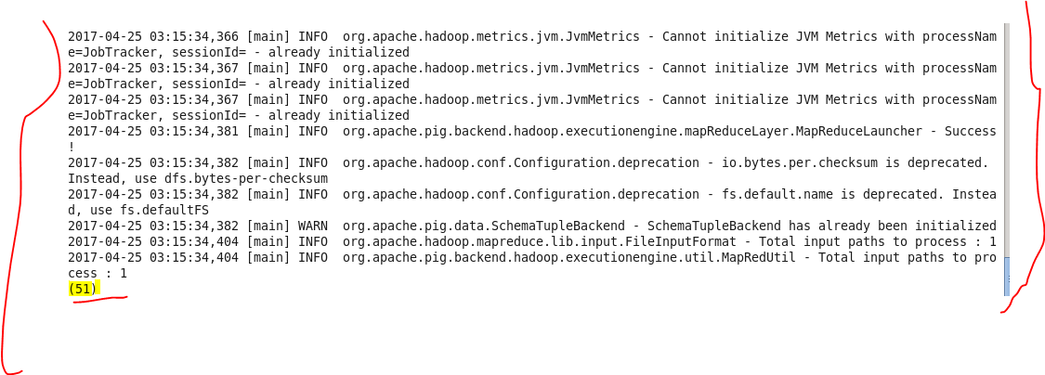

For file FlumeData.1453128879259:

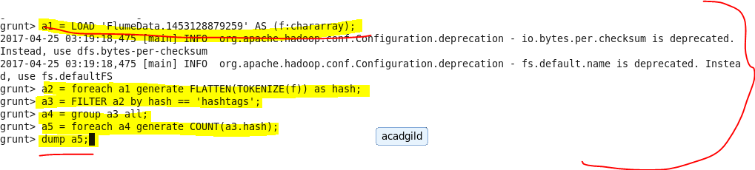

Output :

